Double D Merchant
GRAND OPENING

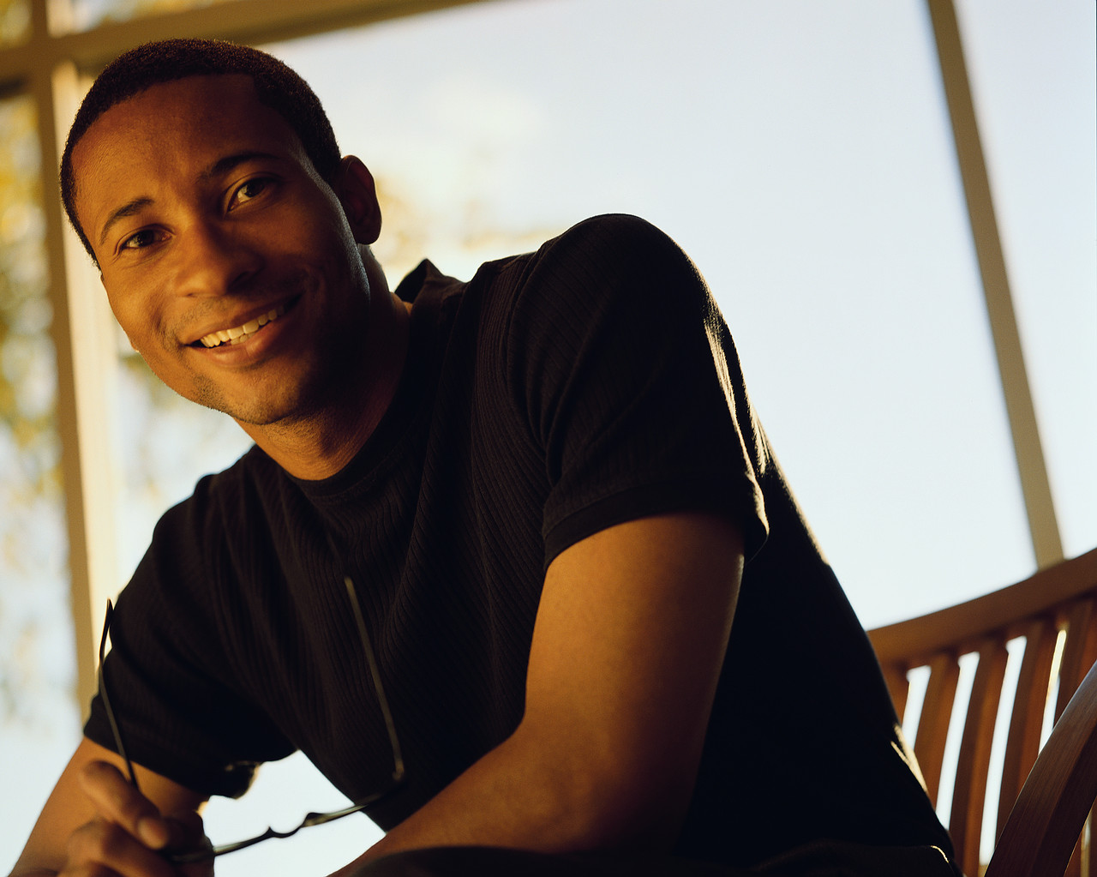

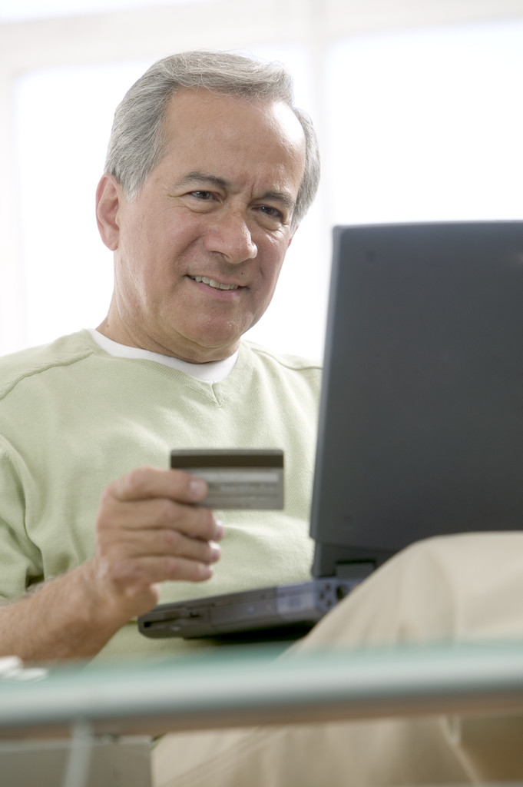


www.d2mo.com

THANK YOU

for attending the Grand Opening for Double D Merchant Online ! The most important part of this event is YOU. Our goal is to serve you and add value to your life with our products and services. Meeting the needs of our guests, customers, and clients is an ongoing process, so we invite you to give some feedback on this event. We appreciate your thoughts about this event and how it can be improved. Please take the time to make notes and comments answering the two questions below . . . please hold nothing back. The success of our company is based on the thoughts and desires of its most important element : YOU.

____________________________________________________________________________________

PLEASE ANSWER THESE TWO QUESTIONS

1) What did you like about this event ?
2 ) What would you change ?

____________________________________________________________________________________________________________________________________________________________________________________________________________________________________________________________________
____________________________________________________________________________________________________________________________________________________________________________________________________________________________________________________________________

THANK YOU FOR YOUR FEEDBACK !!!

Double D Merchant Online
NEEDS ASSESSMENT SURVEY

GET FREE STUFF !!!

Name _______________________________________
Address _______________________________________
Phone ______________________
Email ______________________

May we put you on our email newsletter list ? _______
_________________________________________
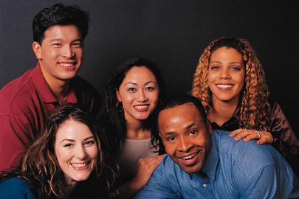

BASIC QUESTIONS

1 ) Is health and or nutrition important to you ??? __________

2 ) Do you work out or play any kind of sports ??? __________

3 ) Do you shop online ? __________

4 ) Which ONE is more important to you PRICE, QUALITY or SERVICE ? __________

FOOD AND DRINK BUDGET

HOW MUCH DO YOU SPEND EACH WEEK ON THINGS LIKE :

( SPORT ) ENERGY DRINKS - PROTEIN SHAKES - GRANOLA BARS - GATORADE . . . ETC __________

( EATING OUT ) Breakfast, Lunch, Dinner - Vending Machines - Gas Station snacks / food __________

( SCHOOL / WORK ) Meals / Beverages / Cafeteria __________

( EVENTS / SPECIAL ) Starbucks / Krispy Crème / Fast Food / Sports / Concerts __________

HOW MUCH DO YOU SPEND EACH MONTH
ON VITAMINS AND SUPPLEMENTS ? __________

_______________________________________________________________________________________

CHECK OFF THE FOLLOWING STATEMENTS WHICH APPLY TO YOU :

_____ I like to do research on a new product before I buy it. ( Example: going online - )

_____ I want to know what my friends and family think of a product before I try or buy.

_____ It matters to me if other people are using a product I try or buy.

_____ I will try a new product if there is a satisfaction and money back guarantee.

_____ I don’t care about researching a product, I just want it to taste good and work !

_____ I like to hear testimonies from third parties before I try or buy a product.

_____ Trusting the company that I buy from is important to me.

WHAT ARE SOME OF YOUR GOALS ?

( Examples : Personal / Health / Financial ) - By what date ???

__________________________________________________________________________________________

________________________________________________________________________________

__________________________________________________________________________________________

________________________________________________________________________________

__________________________________________________________________________________________

________________________________________________________________________________

__________________________________________________________________________________________

________________________________________________________________________________



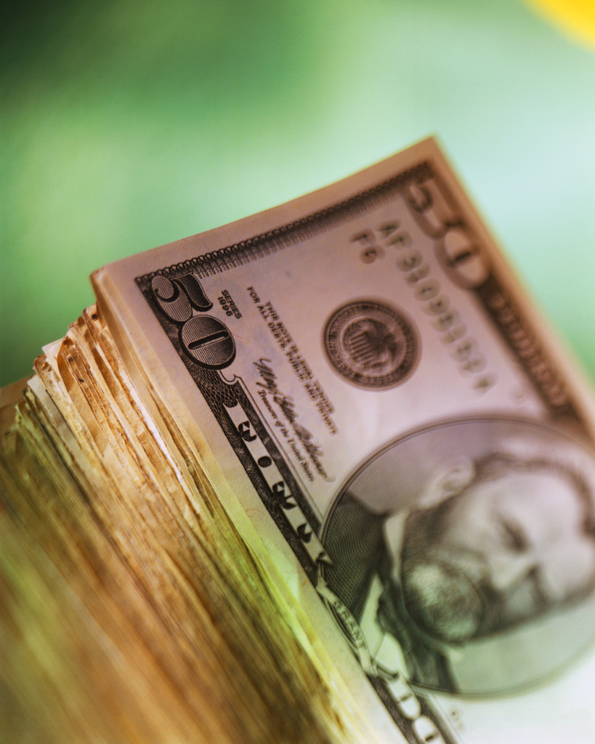

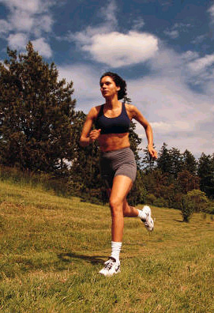

PLEASE CHECK THE PRODUCTS THAT YOU USE NOW OR WOULD LIKE TO SAMPLE FROM D2MO.COM


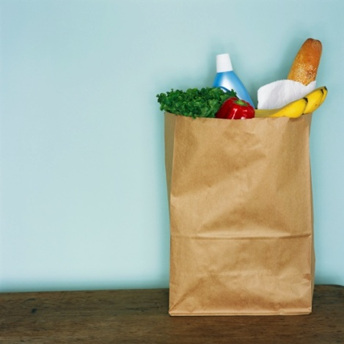


_______ BOTTLED WATER _______ VITAMIN WATER

_______ ENERGY DRINK * _______ ANTIOXIDANT

_______ GATORADE TYPE DRINKS _______ ANTIOXIDANT JUICES

_______ ENERGY BARS _______ ORGANIC PRODUCTS

_______ MEAL BARS _______ FOOD BARS

_______ PROTEIN BARS _______ SUPPLEMENTS

_______ SNACK BARS _______ COOKIES ( Healthy )

_______ MEAL SHAKES _______ PROTEIN SHAKES

_______ CHIPS / BAG SNACKS _______ JUICES / TEAS

What ONE thing would I have to do to earn your business ???

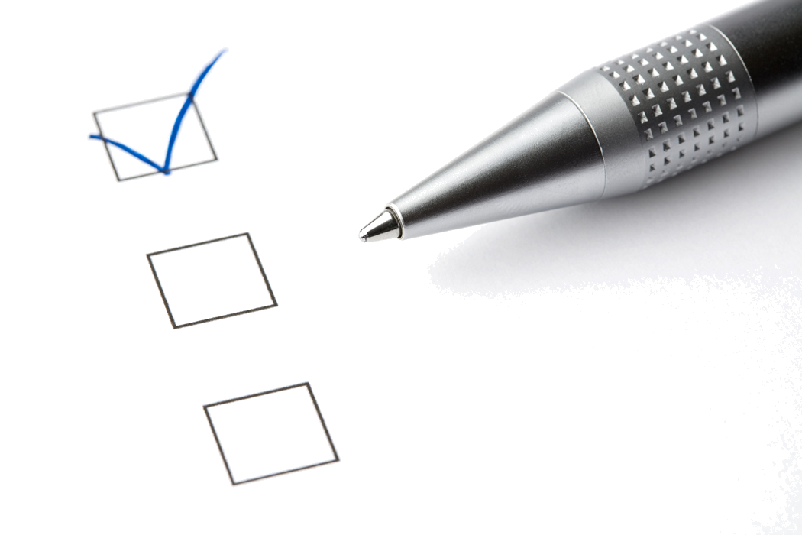

THANK YOU FOR TAKING THIS SURVEY !

DOUBLE D MERCHANT ONLINE

TASTE TESTING / SAMPLING
____________________________________________________________

Below, jot down the names of the products that you like.

1) ____________________________________

2) ____________________________________

3) ____________________________________

4) ____________________________________

5) ____________________________________

6) ____________________________________

7) ____________________________________

8 ) ____________________________________

9) ____________________________________

10) ____________________________________

THANK YOU FOR ATTENDING THE
GRAND OPENING FOR
DOUBLE D MERCHANT ONLINE

PLEASE HAND IN THIS PACKET
SO WE MAY KNOW
HOW TO SERVE YOU IN THE FUTURE.

