d2mo.com - NEEDS ASSESSMENT SURVEY

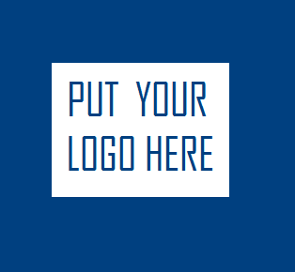
GET FREE STUFF !!!

__________________________________________________________________________________________________

Thank you for taking the time to fill out this short survey for Double D Merchant Online. My company is built on 100% customer needs. Too often in the marketplace, people are pushed and pressured to buy products that they really don’t
need or even worse, placed on a guilt trip with the ridiculous logic of -
“You should buy from me because I’m your friend.”
I don’t believe in conducting business this way. Many people who shop at Double D Merchant Online are my friends and family, but they purchase product because the products bring benefit or add value to their lives.

I ask the same of you if we just met.
PLEASE DON’T purchase my products or services from me because you and I have some kind of relationship or you want “to help me out”. My goal in this part of my company is to service the needs of others – period. It all starts here with this short survey to get an idea of what your needs are. I review the information and take notes before I contact you.

The benefit to you is customized presentations, samplings, and product recommendations that focus directly on you and more importantly – don’t waste your valuable time. It’s about bringing value back to your hard earned dollar.

Thank you again for taking part in this survey.


Duncan DC Dunkins I
OWNER – D2MO.com

BASIC QUESTIONS

1 ) Is health and or nutrition important to you ??? __________
2 ) Do you work out or play any kind of sports ??? __________
3 ) Do you shop online ? __________
4 ) Which is more important to you PRICE, QUALITY or SERVICE ? ( choose only ONE. ) __________

FOOD AND DRINK SHOPPING HABITS

HOW MUCH DO YOU SPEND EACH WEEK ON THINGS LIKE :
( SPORT ) ENERGY DRINKS - PROTEIN SHAKES - GRANOLA BARS - GATORADE . . . ETC __________
( EATING OUT ) Breakfast, Lunch, Dinner - Vending Machines - Gas Station snacks / food __________
( SCHOOL / WORK ) Meals / Beverages / Cafeteria __________
( EVENTS / SPECIAL ) Starbucks / Krispy Crème / Fast Food / Sports / Concerts __________
HOW MUCH DO YOU SPEND EACH MONTH ON VITAMINS AND SUPPLEMENTS ? __________
__________________________________________________________________________________________________
CHECK OFF THE FOLLOWING STATEMENTS WHICH APPLY TO YOU :

_____ I like to do research on a new product before I buy it. ( Example: going online - )
_____ I want to know what my friends and family think of a product before I try or buy.
_____ It matters to me if other people are using a product I try or buy.
_____ I will try a new product if there is a satisfaction and money back guarantee.
_____ I don’t care about researching a product, I just want it to taste good and work !
_____ I like to hear testimonies from third parties before I try or buy a product.
_____ Trusting the company that I buy from is important to me.
WHAT ARE SOME OF YOUR GOALS ? ( Examples : Personal / Health / Financial ) - By what date ???
________________________________________________________________________________________________________________________________________________________________________________________________________________________________________________________________________________________________________________________________________________________________________________________________________
PLEASE CHECK THE PRODUCTS THAT YOU USE NOW OR WOULD LIKE TO SAMPLE FROM D2MO.COM

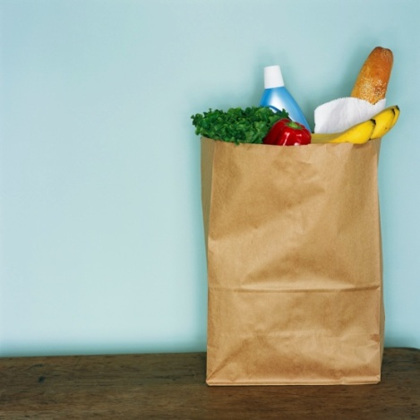


_______ BOTTLED WATER _______ VITAMIN WATER
_______ ENERGY DRINK * _______ ANTIOXIDANT
_______ GATORADE TYPE DRINKS _______ ANTIOXIDANT JUICES
_______ ENERGY BARS _______ ORGANIC PRODUCTS
_______ MEAL BARS _______ FOOD BARS
_______ PROTEIN BARS _______ SUPPLEMENTS
_______ SNACK BARS _______ COOKIES
_______ MEAL SHAKES _______ PROTEIN SHAKES
_______ CHIPS / BAG SNACKS _______ JUICES / TEAS

What ONE thing would I have to do to earn your business ???
_______________________________________________________________________________________________

